Homework Menu
Due Week of 4/8

You must complete each of these five questions. Some are review some are pre-teaching. Some are on our current topic.

 | - Which statement best explains how periods on the periodic table are organized?
 | 2. Why is water from an aquifer more likely to be cleaner than water from other sources?
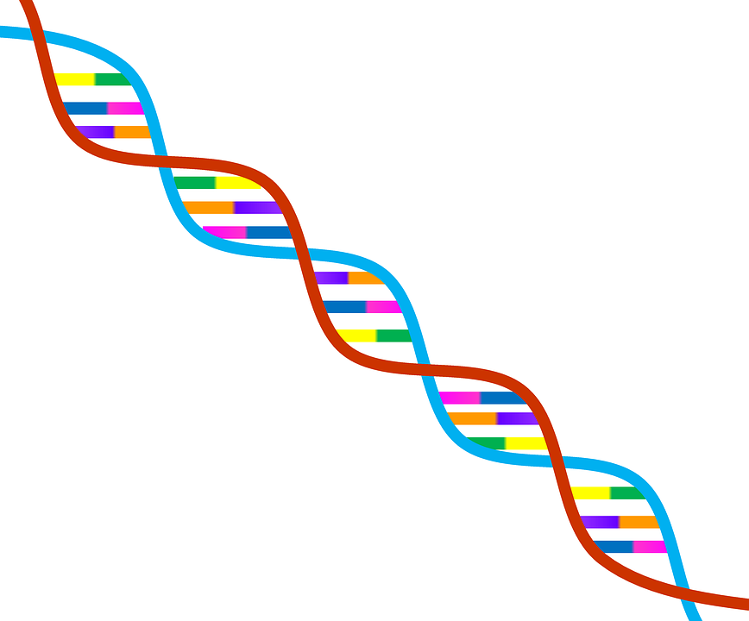 | 3.A. Which is a way the agricultural biotechnology industry could have a positive impact on the environment?  A by producing crops that are virus resistant  B by making robots to replace large farm machines  C by reducing the need for countries to import food  D by increasing the use of wind farms that produce electricity
4. Why is a healthy diet important?
A It maintains a constant body temperature.
B It prevents damage to internal organs.
C It makes oxygen for all the cells in the body.
D It supplies the body’s needs for growth and energy.
5. What is a possible disadvantage of using flowing water to produce electricity?
What are the benefits?
6. What is an example of a renewable energy resource? What does renewable mean?

7. What is an example of a nonrenewable energy source? What is a pro and con for this type of energy?
8. What is a trilobyte? What are they used for/what to they tell us?

9 Name one example of each type of evolution: biological, geological, technological. Choose one type to explain what it means and discuss some of the major changes over time in that category.

